**SUB QUERY**

**Definition:**

1. **Query with in a query** is called sub query.
2. The **inner most sub query is executed first.**
3. We can write **maximum 255 query in a single sub query.**
4. It is **also called as nested query.**
5. Each queries are **separated by () parenthesis.**
6. It is used to **find unknown value.**
7. The output of **inner query** is passed as input to the **outer query.**

**Syntax of a sub-query**

**[ OUTER QUERY ]**  
 **Select …**

**From …**

**Where … ( Select …**

**From …**

**Where …**

**)**

**[ INNER QUERY ]**

**Types of sub query:**

1. Single row sub query
2. Multi row sub query

**Single row sub query:**

1. It is used to return only one output.
2. In this case in between the outer and inner queries we can use = operator.

Ex:

**List the employees working in ‘Research’ department.**

**For ex :-**

**1) List the employees working in ‘Research’ department.**

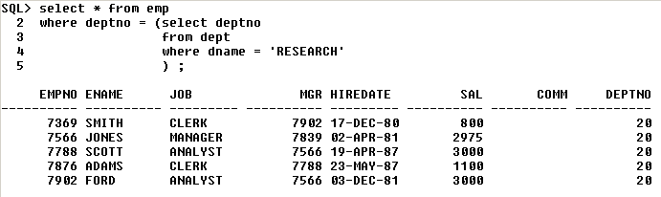

**Multi row sub query:**

1. It is used to **return more than one output.**

In this case **in between outer and inner queries we can use IN operator.**

**Ex:**

**List the employees in Research and Sales department**

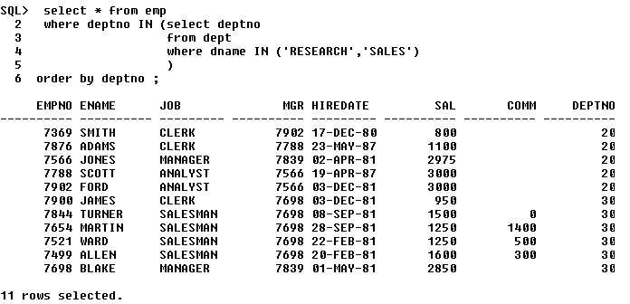

**1) Display the 2nd maximum salary**

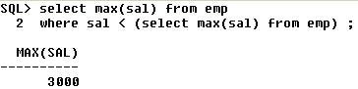

**2) Display the 3rd maximum salary**

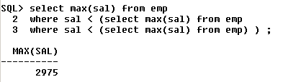

**3) Display the 4th least salary**

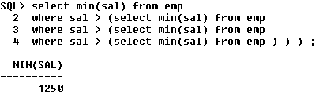

This method is not efficient to find the maximum and minimum salary. The limit is 32. This is not efficient if you want to find the 100th maximum salary.

**We can have upto 32 levels of sub-queries only.**